[Event Title]
To book the JRC Makerspace for an activity, please send this form compiled to:
JRC-MAKERSPACE@ec.europa.eu

Date | Hour | Date | Hours
Contact Person | Coordinator name
Contact e-mail | @ec.europa.eu
Activity Description | Description
Number of Participants | Number of participants (max 35)
Units Involved | Units
Rooms Configuration | Configuration description (e.g. multiple working groups, large exhibition area, creative brainstorming area;…)  Workshop Area:  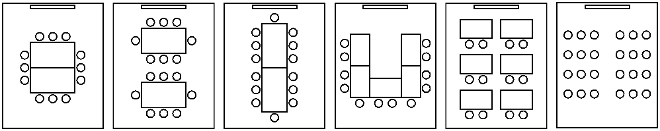  ☐ ☐ ☐ ☐ ☐ ☐
Catering | Catering (Yes/No)
Special Requirements | Requirements (e.g. audiovisual equipment; workshop facilitation kits, group work material; …)

Important Considerations:
- The JRC Makerspace is located at the JRC Ispra site (Italy), in building 17, room 14.
- The JRC Makerspace is managed by unit JRC.H1.
- All bookings are subject to confirmation by the team managing the makerspace, and are subject to the availability of the space and equipment.
- The JRC makerspace is equipped with a desktop computer, interactive projector, large TV screen, three whiteboards and two flipcharts. Digital fabrication equipment includes a laser cutter, 3D printer, CNC milling machine, vinyl cutter and sewing machine. Other equipment might be available on request.
- Safety rules must be respected. Any problems with the equipment or furniture must be reported immediately to the JRC Makerspace team, to be fixed.
- The person listed as the coordinator is considered to be the responsible of the event, even if the space will be used by another member of the service, an external trainer or a contractor.
- When the event is over, the JRC Makerspace must be left as it was before the start: clean and tidy. Failure to do this will prevented future usage of the space by the coordinator.
- Catering requests are of the responsibility of the coordinator of the event.
- The JRC Makerspace team reserves the right to take photographs during the event for the purpose of self-promotion of the space. Any photograph considered intrusive can be requested to be deleted. If you wish for your event not to be photographed, please inform the JRC Makerspace team beforehand.

For more information about the JRC Makerspace, please see:
https://cop-demos.jrc.ec.europa.eu/jrc-makerspace

